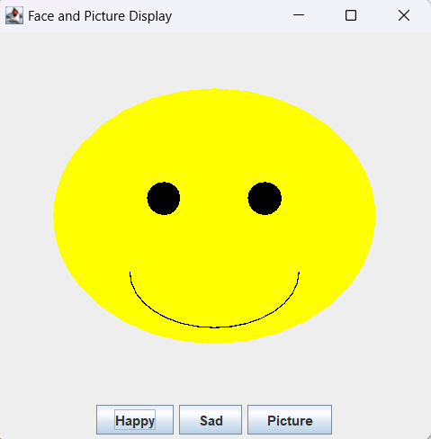

package as17;

import java.awt.Color;
import java.awt.Graphics;
import java.awt.Image;
import javax.swing.ImageIcon;
import javax.swing.JPanel;

public class JPanelExt extends JPanel {
private String pictureType = "Happy";

public void paintComponent(Graphics g) {
super.paintComponent(g);

if (pictureType.equalsIgnoreCase("Happy")) {
// Happy face drawing code
g.setColor(Color.YELLOW);
g.fillOval(50, 50, getWidth() - 100, getHeight() - 100);
g.setColor(Color.BLACK);
g.fillOval(getWidth()/2 - 60, getHeight()/2 - 30, 30, 30);
g.fillOval(getWidth()/2 + 30, getHeight()/2 - 30, 30, 30);
g.drawArc(getWidth()/2 - 75, getHeight()/2, 150, 100, 0, -180);

} else if (pictureType.equalsIgnoreCase("Sad")) {
// Sad face drawing code
g.setColor(Color.CYAN);
g.fillOval(50, 50, getWidth() - 100, getHeight() - 100);
g.setColor(Color.BLACK);
g.fillOval(getWidth()/2 - 60, getHeight()/2 - 30, 30, 30);
g.fillOval(getWidth()/2 + 30, getHeight()/2 - 30, 30, 30);
g.drawArc(getWidth()/2 - 75, getHeight()/2 + 50, 150, 100, 0, 180);

} else if (pictureType.equalsIgnoreCase("Picture")) {
// Picture drawing code - display random picture
displayRandomPicture(g);
}
}

private void displayRandomPicture(Graphics g) {
try {
// Generate random number from 1 to 6
int randomNum = (int)(Math.random() * 6) + 1;
String imageName = "image" + randomNum + ".jpg"; // or .gif

// Try to load the image
ImageIcon imageIcon = new ImageIcon(getClass().getResource(imageName));

if (imageIcon.getImageLoadStatus() == java.awt.MediaTracker.COMPLETE) {
Image image = imageIcon.getImage();
g.drawImage(image, 0, 0, getWidth(), getHeight(), this);
} else {
// If image not found, display a placeholder
g.setColor(Color.LIGHT_GRAY);
g.fillRect(0, 0, getWidth(), getHeight());
g.setColor(Color.BLACK);
g.drawString("Image " + imageName + " not found", getWidth()/2 - 80, getHeight()/2);
g.drawString("Using random color instead", getWidth()/2 - 80, getHeight()/2 + 20);

// Display a colorful pattern as fallback
displayColorPattern(g);
}
} catch (Exception e) {
// Fallback if images are not available
displayColorPattern(g);
}
}

private void displayColorPattern(Graphics g) {
// Create a colorful pattern as fallback when images are not available
int width = getWidth();
int height = getHeight();

// Draw colored rectangles
g.setColor(Color.RED);
g.fillRect(0, 0, width/2, height/2);

g.setColor(Color.GREEN);
g.fillRect(width/2, 0, width/2, height/2);

g.setColor(Color.BLUE);
g.fillRect(0, height/2, width/2, height/2);

g.setColor(Color.ORANGE);
g.fillRect(width/2, height/2, width/2, height/2);

g.setColor(Color.WHITE);
g.drawString("Random Pattern Display", width/2 - 60, height/2);
}

public void setPictureType(String pictureType) {
this.pictureType = pictureType;
this.repaint();
}
}

package as17;

import java.awt.BorderLayout;
import java.awt.event.ActionEvent;
import java.awt.event.ActionListener;
import javax.swing.JButton;
import javax.swing.JFrame;
import javax.swing.JPanel;

public class JFrameExt extends JFrame implements ActionListener {
private JPanelExt jpe = new JPanelExt();
private JPanel jp = new JPanel();

private JButton jbtHappy = new JButton("Happy");
private JButton jbtSad = new JButton("Sad");
private JButton jbtPicture = new JButton("Picture");

public JFrameExt() {
super("Face and Picture Display");

// Create main panel and set as content pane
JPanel jpMain = new JPanel();
jpMain.setLayout(new BorderLayout());
setContentPane(jpMain);

// Add panels to main panel
jpMain.add(jpe, BorderLayout.CENTER);
jpMain.add(jp, BorderLayout.SOUTH);

// Add buttons to south panel
jp.add(jbtHappy);
jp.add(jbtSad);
jp.add(jbtPicture);

// Register action listeners
jbtHappy.addActionListener(this);
jbtSad.addActionListener(this);
jbtPicture.addActionListener(this);
}

@Override
public void actionPerformed(ActionEvent e) {
if (e.getSource() == jbtHappy) {
jpe.setPictureType("Happy");
} else if (e.getSource() == jbtSad) {
jpe.setPictureType("Sad");
} else if (e.getSource() == jbtPicture) {
jpe.setPictureType("Picture");
}
}
}

package as17;

import javax.swing.JFrame;

public class TestJFrameExt {
public static void main(String[] args) {
// Create JFrameExt object
JFrameExt frame = new JFrameExt();

// Set size and make visible
frame.setSize(400, 400);
frame.setDefaultCloseOperation(JFrame.EXIT_ON_CLOSE);
frame.setVisible(true);
}
}

